**INTRODUCTION TO ASYNC PROGRAMMING**

Async (or asynchronous) programming is a proficiency to run multiple operations in our applications inside a single thread. Whatever the nature of your application a web server, a database or an operating system, using async programing you can get the most out of the underlying hardware.

In Rust, when we talk about async, we’re talking about running code concurrently, or having multiple operations running on a single thread. Multi-threading is a related, but a different concept. Multithreading is ideal for when you’ve got computationally intensive tasks that can be spread across multiple cores

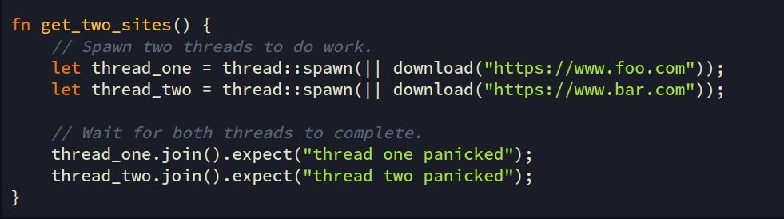In a multi-threaded application, if you wanted to download two different webpages at the same time, you would spread the work across two different threads. For example: